**Icp -6**

**Ghithub link:**

https://github.com/poojasrinivas29/icp6.

**Video Link:** https://drive.google.com/file/d/1holuL0cFTbtXPJ76qJI_tC-OO5pzZ3EX/view?usp=sharing

1). Add one more hidden layer to autoencoder

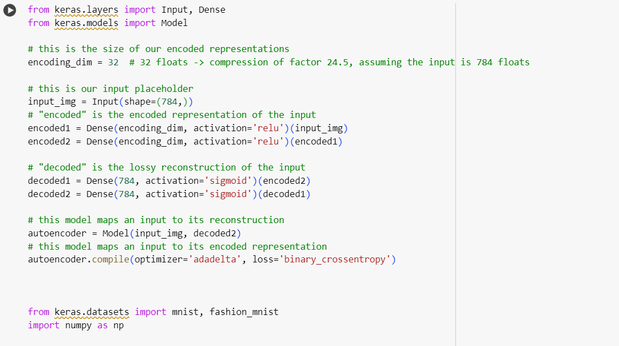

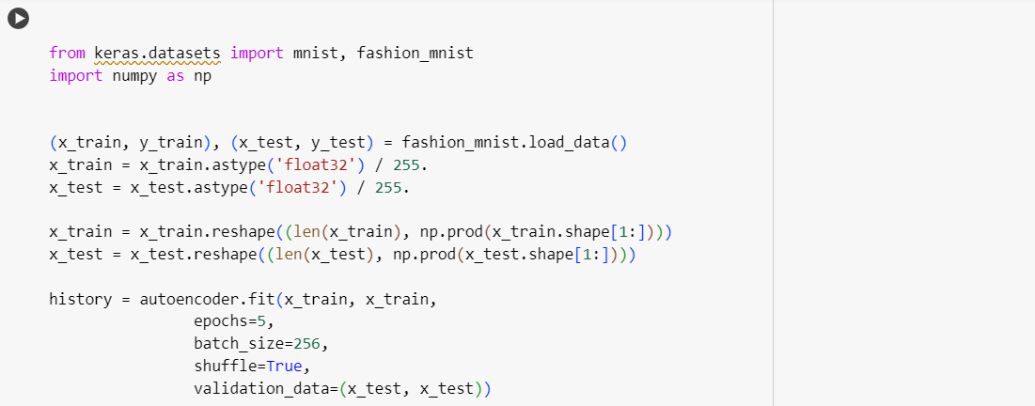

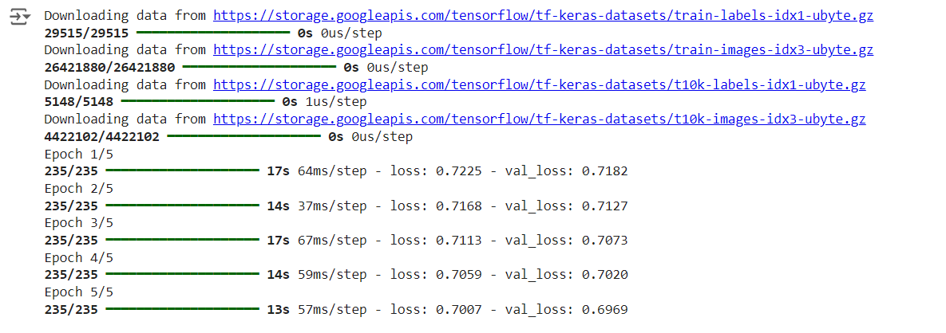

2). Do the prediction on the test data and then visualize one of the reconstructed version of that test data. Also, visualize the same test data before reconstruction using Matplotlib

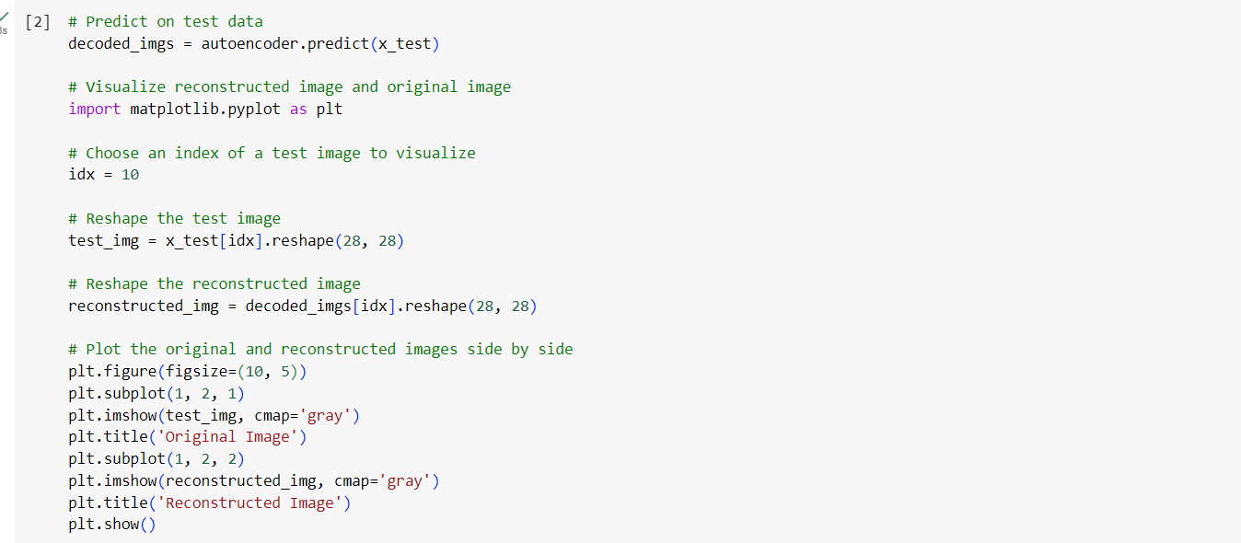

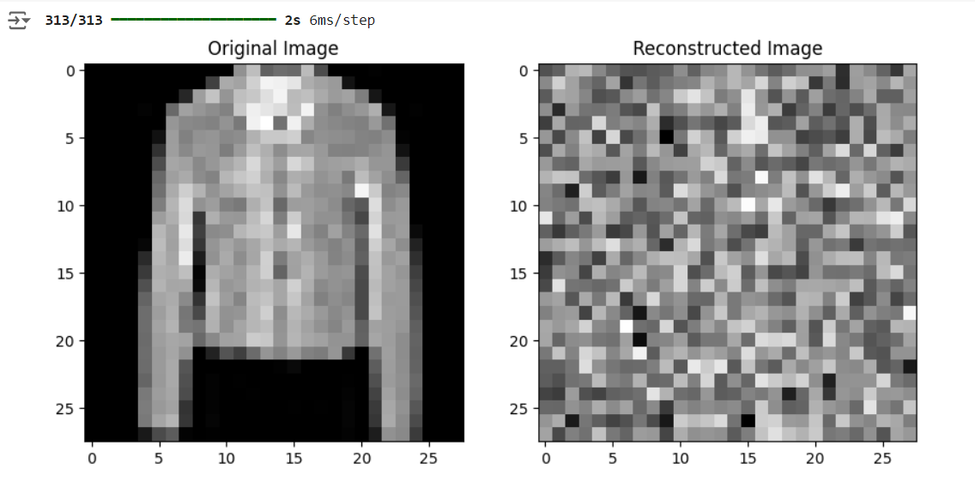

3). Repeat the question 2 on the denoisening autoencoder

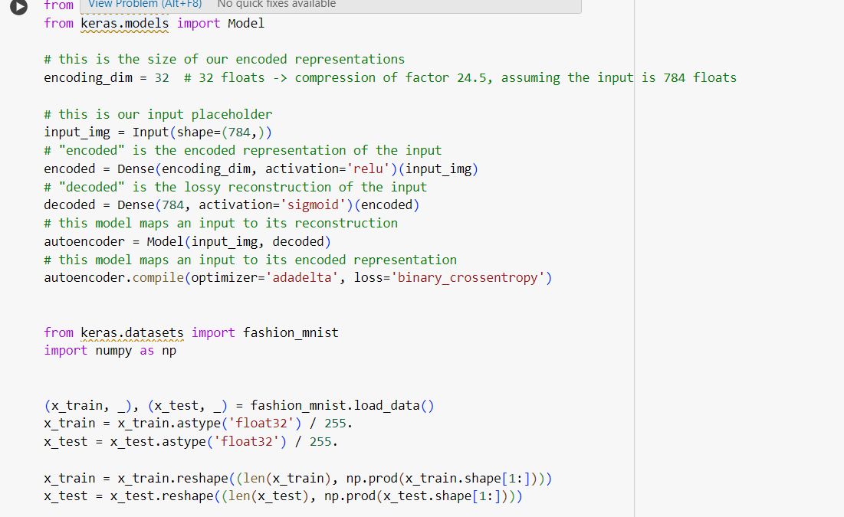

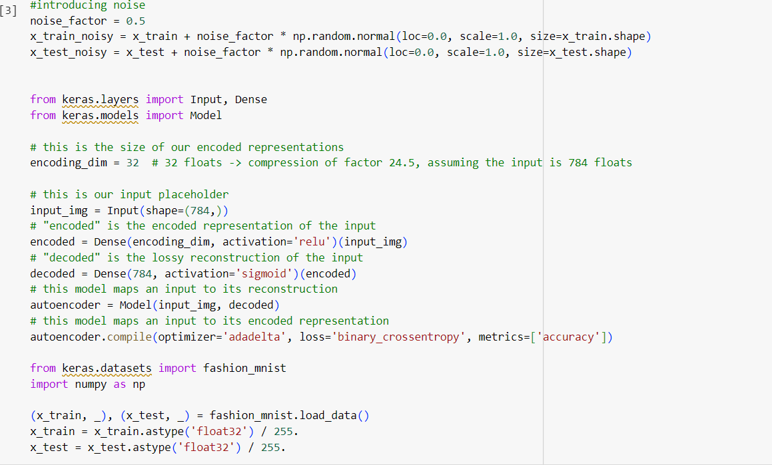

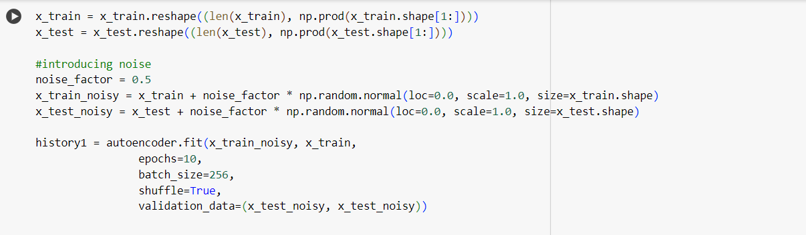

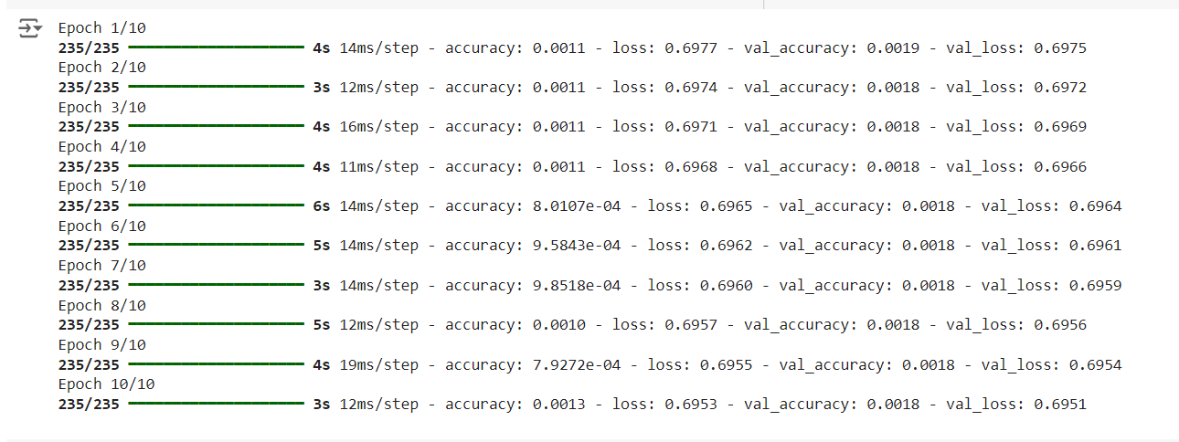

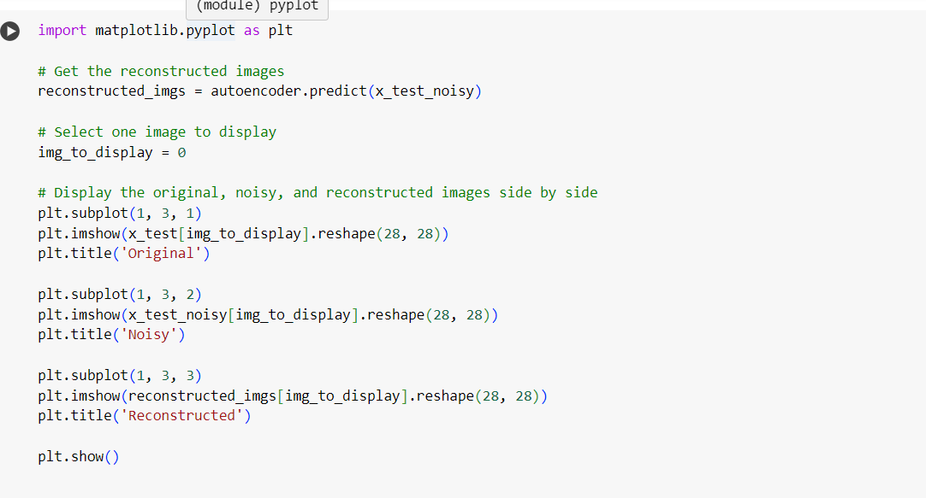

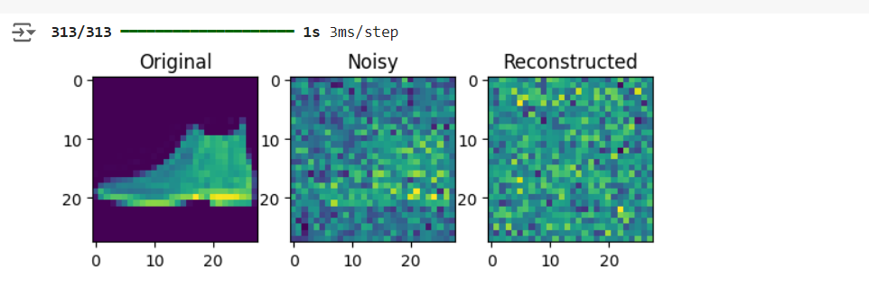

4. plot loss and accuracy using the history object

